Kirissa Byington

10/3/25

CS 499

Enhancement Two: Narrative

For Enhancement Two within my ePortfolio I chose an artifact that was previously made back in December 2024 as part of a final project for CS 320. This artifact is a set of Java classes and Java Test classes to utilize JUnit testing for managing appointment software. The artifact includes three main class areas Appointment, Contact, and Task. Each of these classes has corresponding test classes to validate the original classes, and methods are correct and functional.

I selected this artifact since it easily demonstrates my ability to apply techniques for enforcing data integrity through immutable objects, validating logic, as well as showing my skills with defensive programming through the use of testing. This artifact highlights my skills with creating comprehensive unit tests to not only detect correct data manipulation but also prevent unwanted data manipulation. Another skill displayed using this artifact is the ability to integrate boundary and null testing to prevent errors in the application. These skills assist in showcasing my understanding of algorithms and data structures through how the data is validated and protected throughout a system.

Improvements made to this artifact include ensuring security through making taskID immutable, handling null appointments, as well as detecting failures within updating variables. Another improvement showcases in this enhancement included expanded on the many original test cases to cover a wider range of security risks such as invalid inputs and edge cases. I also ensured that I improved and updated my inline comments for a more professional and readable application.

The course outcomes I had stated that would be met through this enhancement were indeed met. For the course outcome: “Develop a security mindset that anticipates adversarial exploits in software architecture and designs to expose potential vulnerabilities, mitigate design flaws, and ensure privacy and enhanced security of data and resources,” I made taskID immutable which showcases my proficiency with ensuring validation through defensive coding strategies. For the second course outcome to be met through this enhancement, “Employ strategies for building collaborative environments that enable diverse audiences to support organizational decision-making in the field of computer science,” I ensured that the inline comments were organized and professional for better overall readability and accessibility.

Upon my reflection of this enhancement, I would agree that this artifact enhancement assisted with deepening my overall understanding of software design and ensuring security is throughout. I learned more in depth that utilizing final when creating a constructor can assist with immutability and security. The biggest challenge I faced throughout this enhancement would be utilizing the Java language. As a prospective Data Analyst, my primary experience lies in SQL and Python. I initially encountered challenges with Java during previous coursework. However, working on this project and conducting research to understand the syntax and its applications significantly enhanced my overall Java proficiency.

First Test:

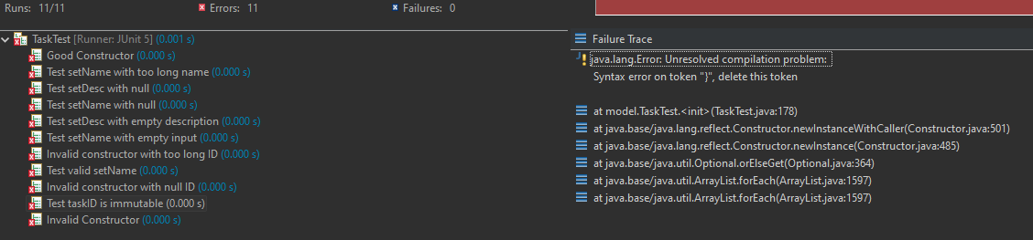

Final Test:

